**Contents**

Introduction……………………………………………………………………….

Team Members………………………………………………………………….

Roles………………………………………………………………………………….

Gantt Chart…………………………………………………………………………

Wireframes…………………………………………………………………………

Main Work Screenshots…………………………………………………….

Conclusion………………………………………………………………………….

## **INTRODUCTION**

With the help of agile mythology, we create an android application on health care chart. Firstly, user must create an account for run the application after login the patient can easily book the appointment and fill each important information that doctor need about the patient like which doctor, they want to meet, prescription, conditions, medical notes, allergies, vaccines etc. Also, this application is multiuser with CRUD operations.

# **TEAM MEMBERS**

**1.Jaskaran Singh**

**2.Harman Virk**

**3.Baljinder Ranu**

**4. Gagandeep Kaur**

**5. Sukhjeet Kaur**

## **ROLES**

**Jaskaran Singh** : Product Owner

**Harman Virk** : Scrum Master and Stakeholder

**Baljinder Ranu** : Front End-Developer

**Gagandeep Kaur:** Back End- Developer

**Sukhjeet Kaur:** Tester

## **GANTT CHART**

## **Wireframes**

Signup page

Home page

Appointment

**Doctors**

Calendar

Notes

## **Main Work** **SCREENSHOT**

Sign-up page- for starting this application user need to do signup firstly to run the application they have to fulfil some needed detail such as name, birthday and email. After that they must submit.

Home Page- after login user will reach to home page that will show them some option such as they can book appointments, add doctors, prescriptions, their condition, allergies and book vaccines.

Appointment- for book an appointment to doctor patient need to fill some needed information in this page.

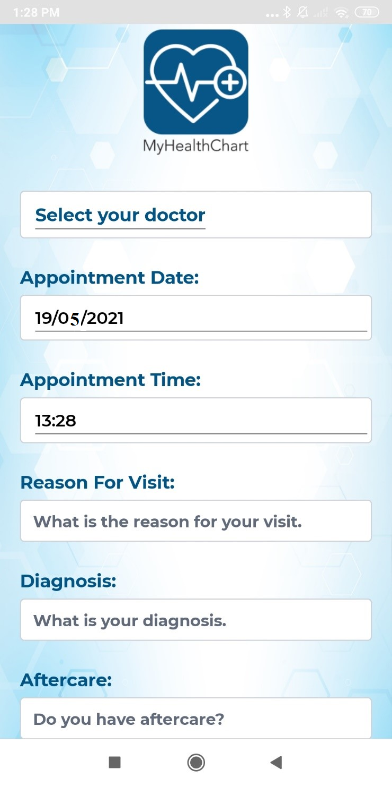

Doctor- in this page patient can choose their doctor according to their condition it will show them types of doctors and their practice.

Calendar – In calendar a patient can see their booked appointment as a reminder.

Notes- A doctor can give any note to patient with description as well as doctor will also add special folder for patient.

## **Conclusion**

The main aim of agile methodologies is to deliver what is needed when it is needed and nothing more. To sum up, this application is mainly for the patient to access from home for their appointments which save their time additionally they will easily explain their condition to their doctor. If this application get chance to interact in market this will be suitable for the target audience and fulfil its main purpose.